**HTML: The Building Blocks of the Web**

Imagine HTML as the blueprint for a house. It defines the structure of a web page, telling the browser where to put headings, paragraphs, images, and other content. It's like secret language browsers understand, turning your code into the vibrant webpages you see every day.

**A Simple HTML Document: Let's Build a Basic House**

Think of a simple HTML document as a basic house with a roof, walls, and a floor. Here's a breakdown:

* **<!DOCTYPE html>:** This line acts like the foundation, declaring the document as HTML.
* **<html>:** This tag is the roof, marking the start of the HTML code.
* **<head>:** This section is like the attic, holding information not displayed on the page, like the title.
* **<body>:** This is the main floor, containing all the visible content like headings, paragraphs, and images.
* **</html>:** This tag signifies the end of the roof, closing the HTML document.

**Example Explained: Bringing the House to Life**

Let's say you want to create a simple webpage with the title "Awesome Weather" and a heading that says "Welcome!" Here's the HTML code:

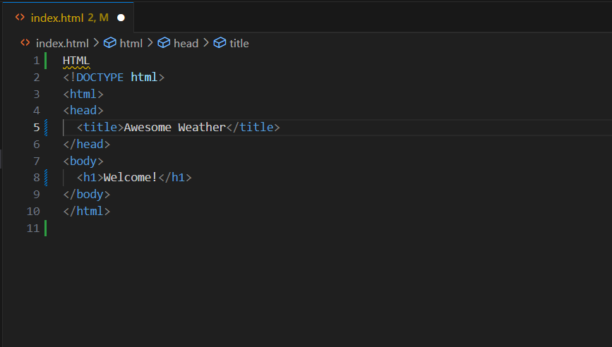

This code defines the structure: the title goes in the attic (head), and the heading "Welcome!" occupies the main floor (body).

**What's an HTML Element? The Bricks and Mortar**

Imagine breaking down the house into smaller parts like walls, doors, and windows. These are like HTML elements, the building blocks that define different parts of your webpage content. They use tags like <p> for paragraphs and <h1> for headings.

The HTML **element** is everything from the start tag to the end tag:

<tagname>Content goes here...</tagname>

Examples of some HTML elements:

<h1>My First Heading</h1>

<p>My first paragraph.</p>

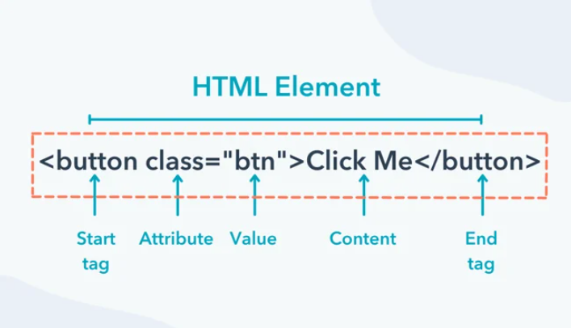

**Web Browsers: The Architects**

Web browsers are the skilled workers who take your HTML blueprint and turn it into a real house (webpage) you can see. They interpret the HTML code and display the content accordingly.

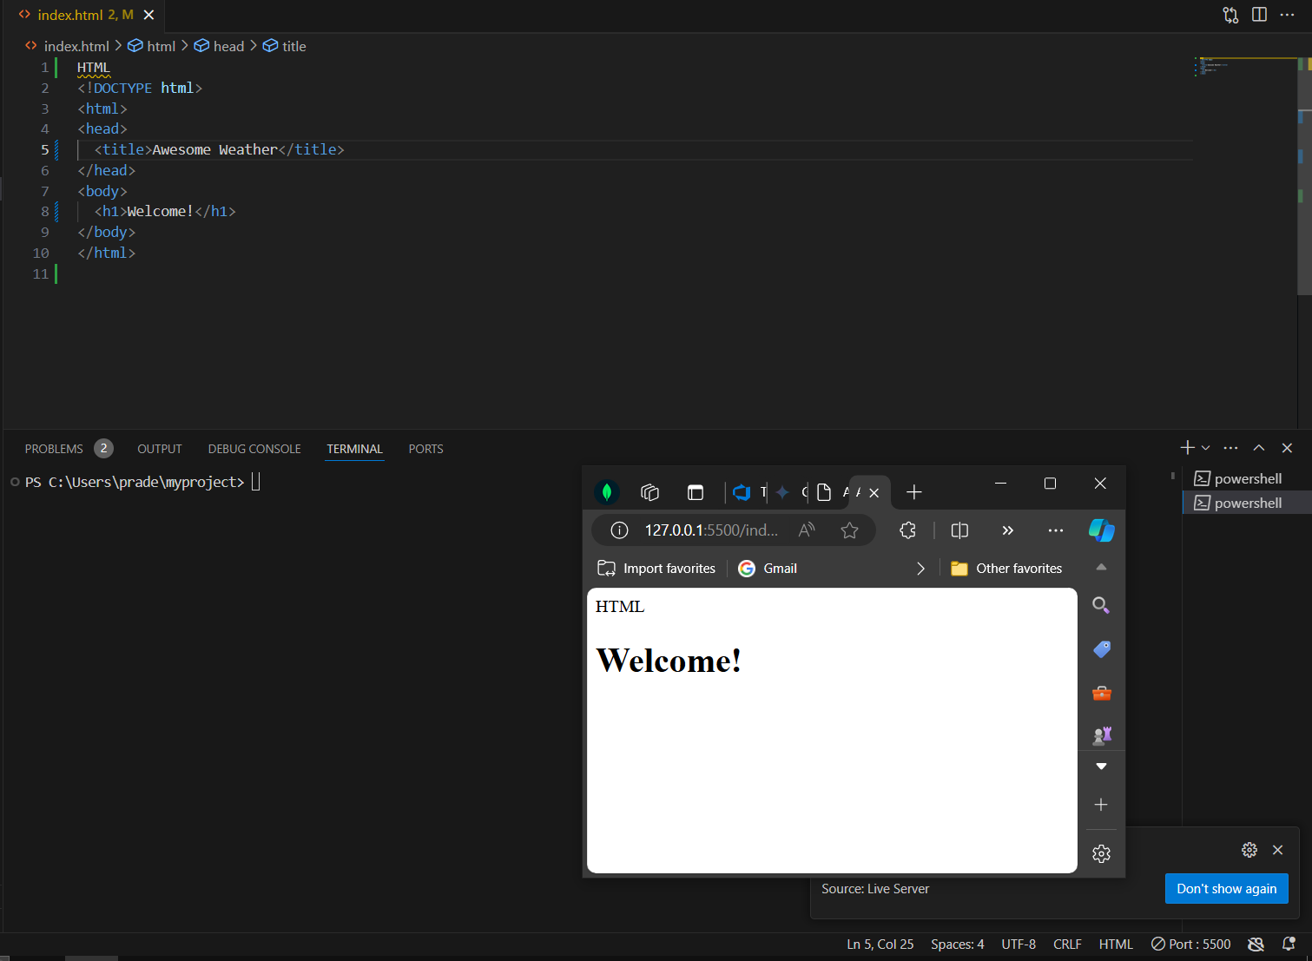

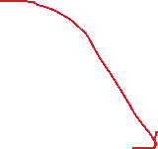

**HTML Page Structure: Organizing Your House**

Just like a house has a logical flow, an HTML page needs structure. Headings act like floor numbers, guiding users through the content. Paragraphs are rooms, and images can be decorative paintings.

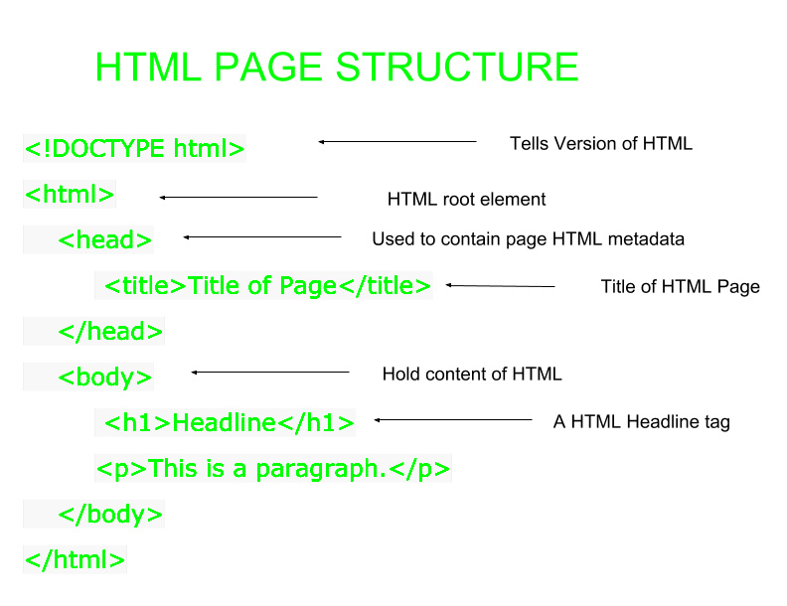

**HTML History: A Short Walk-Through Time**

HTML has a rich history, constantly evolving to meet the web's growing needs. It all started in the late 1980s as a way to share information between scientists. Today, it's the foundation of the web, allowing anyone to create interactive and visually appealing websites.

**Learning HTML: Easy as Notepad or TextEdit**

The beauty of HTML is that you can start coding with just a simple text editor like Notepad (Windows) or TextEdit (Mac). No fancy software needed!

**Basic Examples: Let's Practice Building**

Ready to get your hands dirty? There are many online tutorials and resources that provide step-by-step guides to writing basic HTML code. Experiment with different elements and structures to get comfortable building your web house.

**HTML Documents: The Blueprint in Detail**

As you venture further, you'll devlop deeper into specific parts of an HTML document, like the <!DOCTYPE> declaration that specifies the document type and the various elements that create different sections of your webpage.

**The <!DOCTYPE> Declaration: Setting the Ground Rules**

Imagine a house built with different materials depending on the local building code. The <!DOCTYPE> declaration acts similarly, informing the browser about the HTML version you're using, ensuring everything displays correctly.

**HTML Headings: Signposts for Your Visitors**

Headings are like prominent signs in your house, guiding visitors to different sections. HTML offers various heading tags (h1 to h6) to structure your content hierarchy, from the main title (h1) to subheadings (h2, h3, etc.).

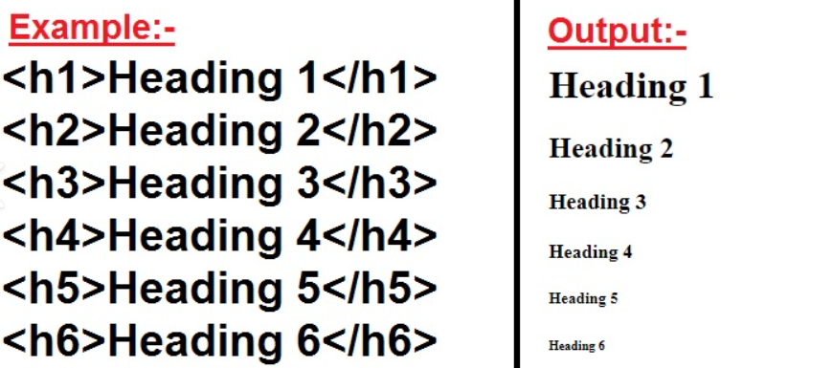

**Embrace the Power of Elements: From Paragraphs to Images**

There's a vast collection of HTML elements for different content types. You'll use <p> for paragraphs, <h1> for headings, <img> for images, and many more to bring your webpage to life.

**Nesting Elements: Building Floors Within Floors**

Imagine creating a cozy reading nook within a room. This is like nesting elements in HTML. You can place one element inside another to create a more complex structure. For instance, you can put bold text (<strong>) within a paragraph (<p>).

**Never Skip the End Tag: Closing the Door on Confusion**

Just like every door need closing, every opening HTML

**HTML: Part Two**

**Empty HTML Elements: Tiny Houses, Big Purpose**

Imagine a little mailbox on your house's exterior. That's similar to an empty HTML element. It represents content that doesn't require an ending tag, like the <br> tag for inserting a line break or the <hr> tag for a horizontal rule. They perform an action and that's it!

**Case-Insensitive? HTML Doesn't Mind Your Caps Lock**

Unlike proper nouns, HTML tags are cool with how you capitalize them. Whether you write <body> or <BODY>, the browser interprets them the same way. This makes HTML more forgiving for beginners.

**HTML Attributes: Adding Flair to Your House**

Think of attributes as the decorative touches that personalize your house. In HTML, attributes provide additional information to an element, often placed within the opening tag. For instance, the href attribute in an <a> tag specifies the link's destination URL.

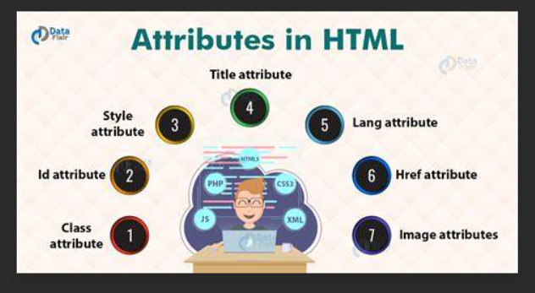

**The href Attribute: Your Teleportation Device**

The href attribute is like a magic doorway in your house. Used with the <a> tag, it creates hyperlinks that, when clicked, transport users to another webpage or a specific location on the current page.

**HTML Headings: Announcing Each Room with Style**

We mentioned headings before, but here's a fun way to imagine them. Headings are like signs above each doorway, announcing the room's purpose with different sizes and styles. HTML offers multiple heading levels (h1 to h6) to create a hierarchy, from the grand entrance (h1) to smaller subheadings (h2, h3, etc.).

**HTML Paragraphs: The Storyteller in Your House**

Paragraphs are the storytellers in your house, weaving narratives or sharing information. The <p> tag defines a paragraph, letting the browser know where one thought ends and another begins.

**HTML Horizontal Rules: The Dividing Lines**

Imagine a decorative stripe separating rooms on your floor. The <hr> tag creates a horizontal rule, visually dividing your webpage content and improving readability.

**HTML Styles: Taking Design to the Next Level (Bonus!)**

While HTML defines structure, CSS (Cascading Style Sheets) adds the aesthetic touch. Think of CSS as the interior designer, choosing colours, fonts, and layouts to make your webpage visually appealing. This is a separate language but often works hand-in-hand with HTML.

**HTML Tables: The Organizational Powerhouse**

Tables are like filing cabinets in your house, organizing information in rows and columns. They use tags like <table>, <tr> for table rows, and <td> for table data cells. This allows for presenting structured content in a clear and efficient way.

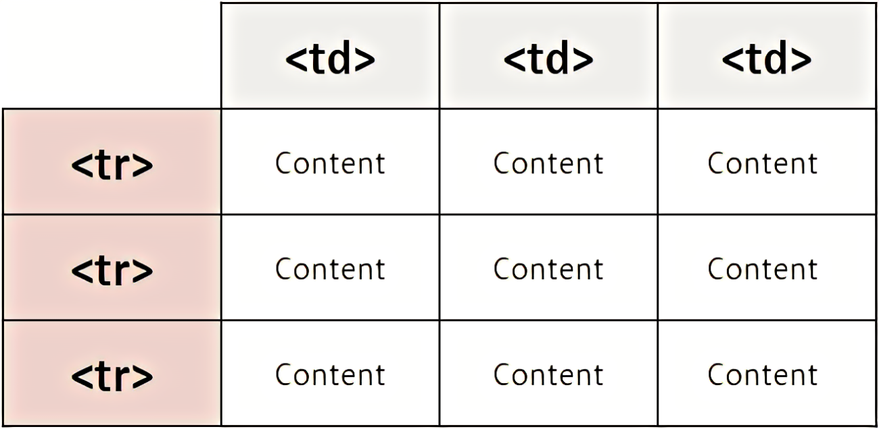

**HTML Text Formatting: Bold, Italic, and Underlined Emphasis**

Want to highlight important parts of your house tour narrative? HTML offers tags like <strong> for bold text, <em> for italics, and <u> for underlining. These add emphasis to specific text elements, guiding your visitors' attention.